Shalom Everyone:

Those experiments will be taken care of by our mechanical Testing specialist, Andrey Garkun cc’ed here (0545240764)

Evgeny, I suggest you contact Andrey to take part to the experiments.

Kind regards

Dear professor Rittel

I hope you are doing well, following our last conversation the experimental guide lines are:

1. There are three types of specimens:
   1. Black specimens – composite
   2. 7 mm diameter specimens – Epoxy resin 1
   3. 9 mm diameter specimens – Epoxy resin 2
2. For each type of materials we would like to get stress strain curves at nominal strain rates of (1000,2000,3000 1/s)
3. To validate the results, please test at least 2-3 specimens at each strain rate
4. Final report of the outcome

If possible, I would like Evgeni to be present during the experiments and the setup perpetration

Thanks in advance



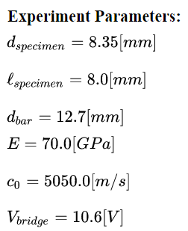

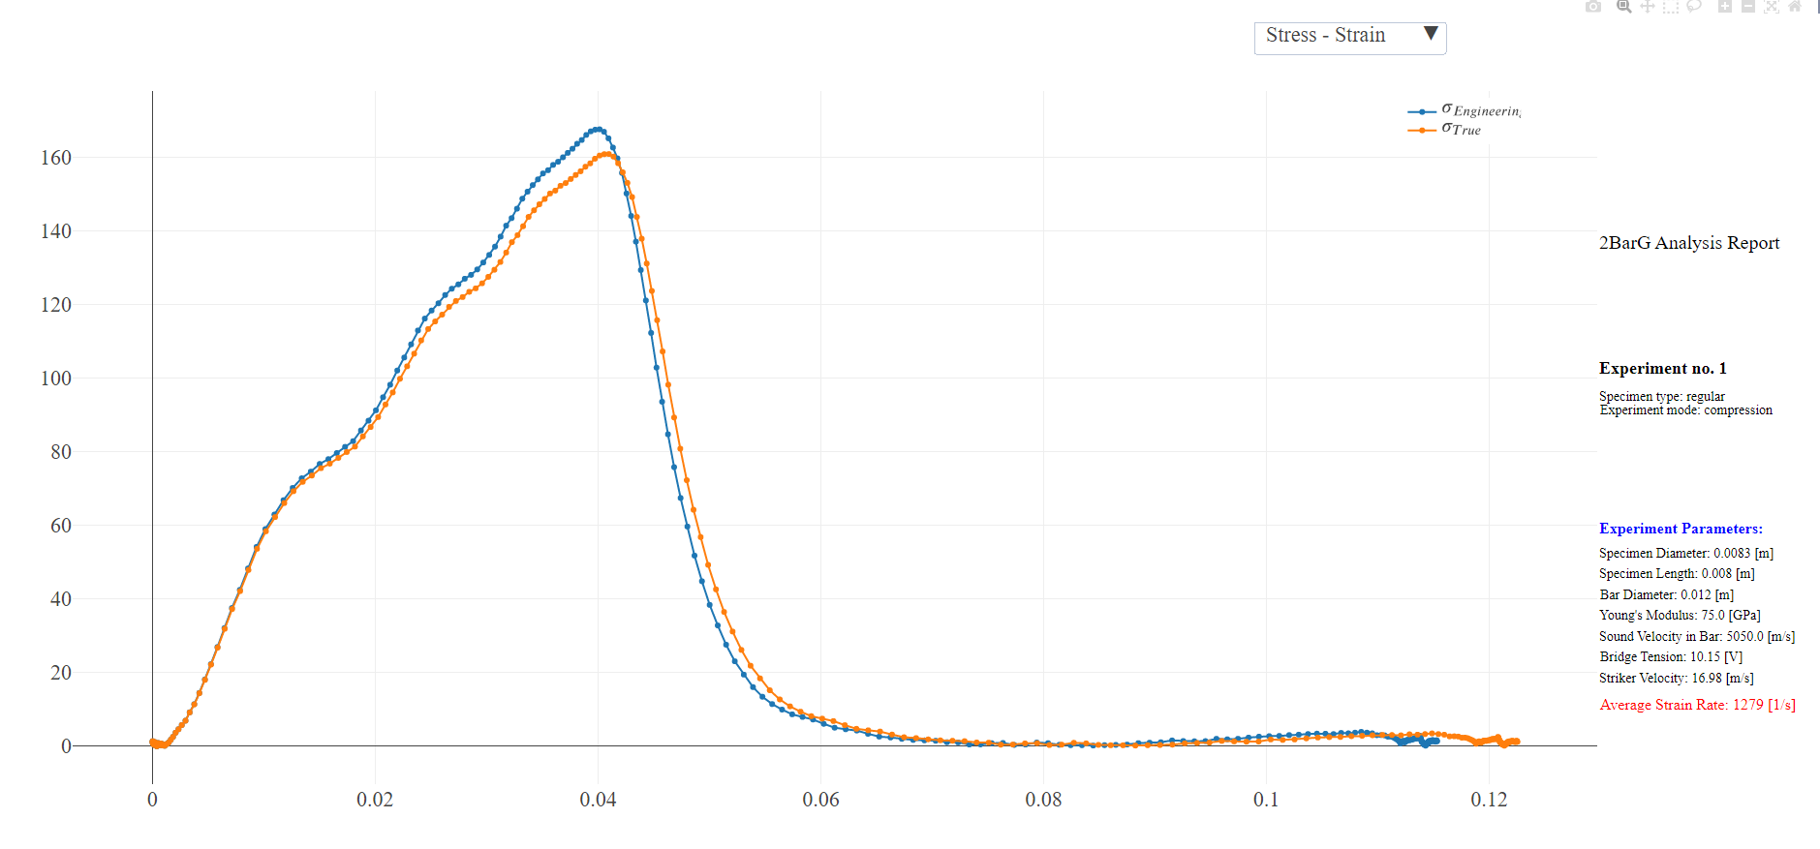

Fig.1. Black specimens – composite #1.

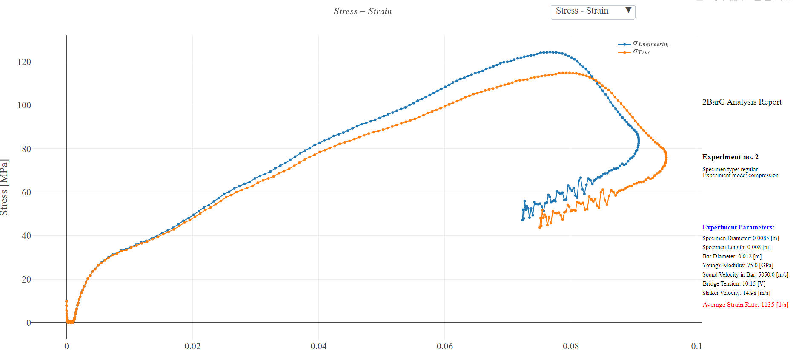

Fig.2. Transparent specimens – Epoxy resin 1 #1.

Strain rate, ≈1000 s-1

|  |  |  |  |  |  |  |
| --- | --- | --- | --- | --- | --- | --- |
| Strain at max stress | Max stress, MPa | Strain rate, s-1 | Length, mm | Diameter, mm | Specimen # | |
| Black specimens – composite | | | | | | |
| 0.02 | 174.6 | 590 | 8.1 | 8.37 | C1 | 1 |
| 0.07 | 125.2 | 1045 | 7.3 | 8.32 | C2 | 2 |
| 0.02 | 164.4 | 704 | 8.1 | 8.35 | C3 | 3 |
| 7mm diameter specimens – Epoxy resin 1 | | | | | | |
| 0.05 | 71.3 | 1283 | 8.6 | 8.9 | E1-1 | 4 |
| 0.04 | 93.5 | 1075 | 8.8 | 8.9 | E1-2 | 5 |
| 0.05 | 98.3 | 1135 | 8.3 | 9.0 | E1-3 | 6 |
| 9mm diameter specimens – Epoxy resin 2 | | | | | | |
| 0.03 | 62.8 | 968 | 11.5 | 11.9 | E2-1 | 7 |
| 0.03 | 78.9 | 886 | 11.2 | 12.0 | E2-2 | 8 |

Strain rate, ≈2000 s-1

|  |  |  |  |  |  |  |
| --- | --- | --- | --- | --- | --- | --- |
|  |  | Strain rate, s-1 | Length, mm | Diameter, mm | Specimen # | |
| Black specimens – composite | | | | | | |
| 0.15* | 156.9 | 1974 | 8.2 | 8.35 | C1 | 1 |
| 0.20* | 153.7 | 2792 | 7.1 | 8.28 | C2 | 2 |
| 0.18* | 205.3 | 1995 | 8.1 | 8.35 | C3 | 3 |
| 7mm diameter specimens – Epoxy resin 1 | | | | | | |
| 0.09 | 123.7 | 2022 | 8.6 | 8.97 | E1-3 | 4 |
| 9mm diameter specimens – Epoxy resin 2 | | | | | | |
| 0.06 | 108.4 | 1415 | 11.4 | 12.0 | E2-2 | 5 |

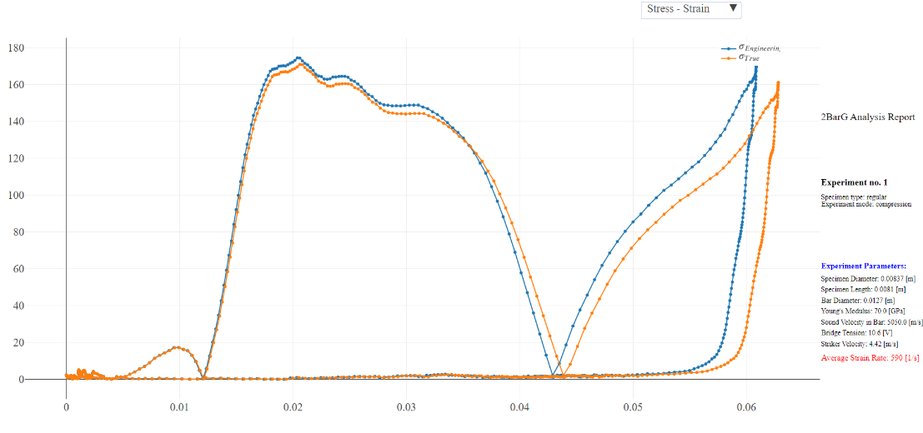

Fig.1. Black specimens – composite #1.

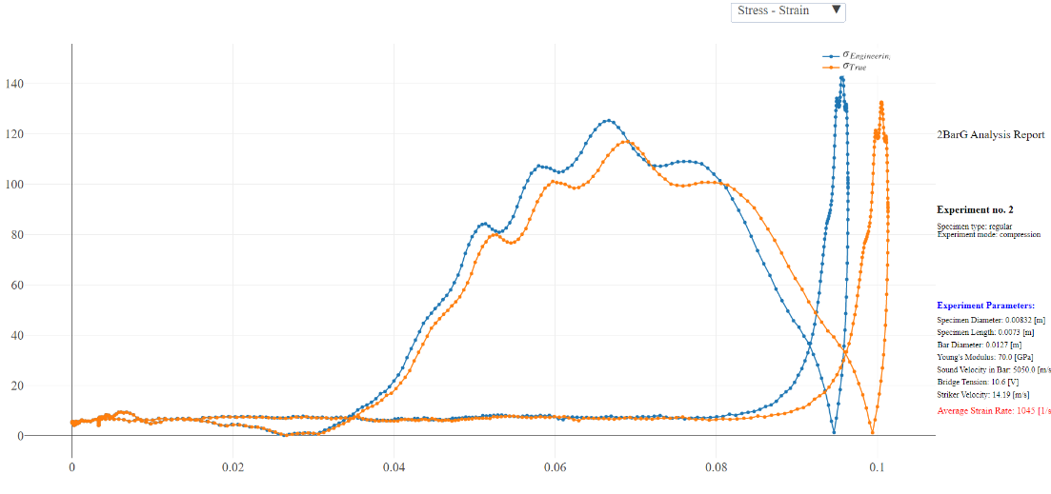

Fig.2. Black specimens – composite #2.

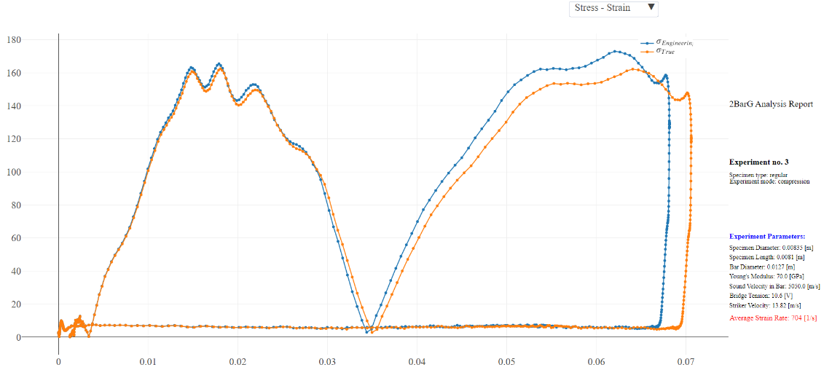

Fig.3. Black specimens – composite #3.

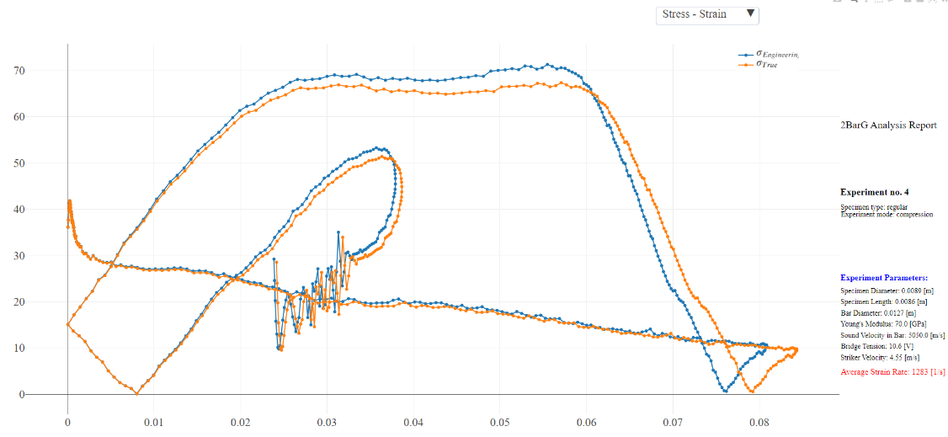

Fig.4. Transparent specimens – Epoxy resin 1 #1.

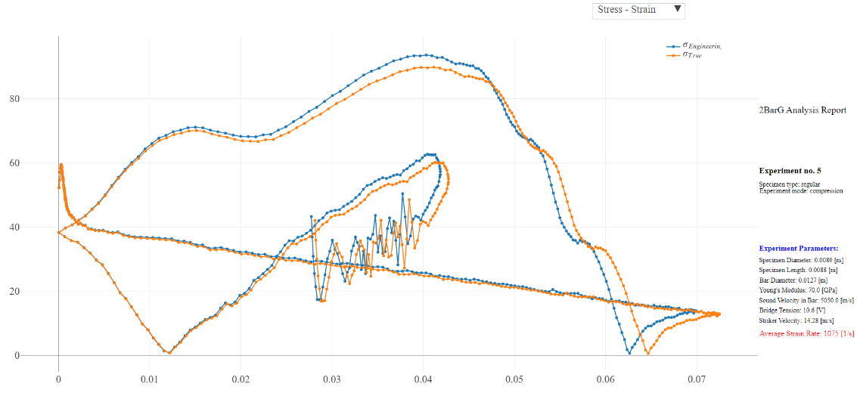

Fig.5. Transparent specimens – Epoxy resin 1 #2.

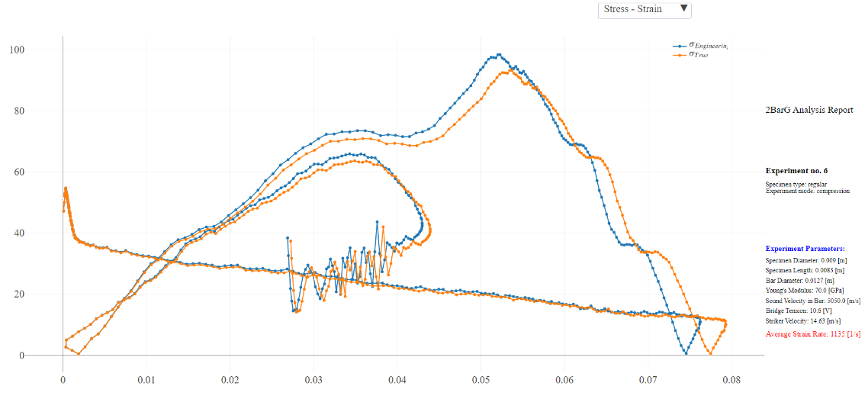

Fig.6. Transparent specimens – Epoxy resin 1 #3.

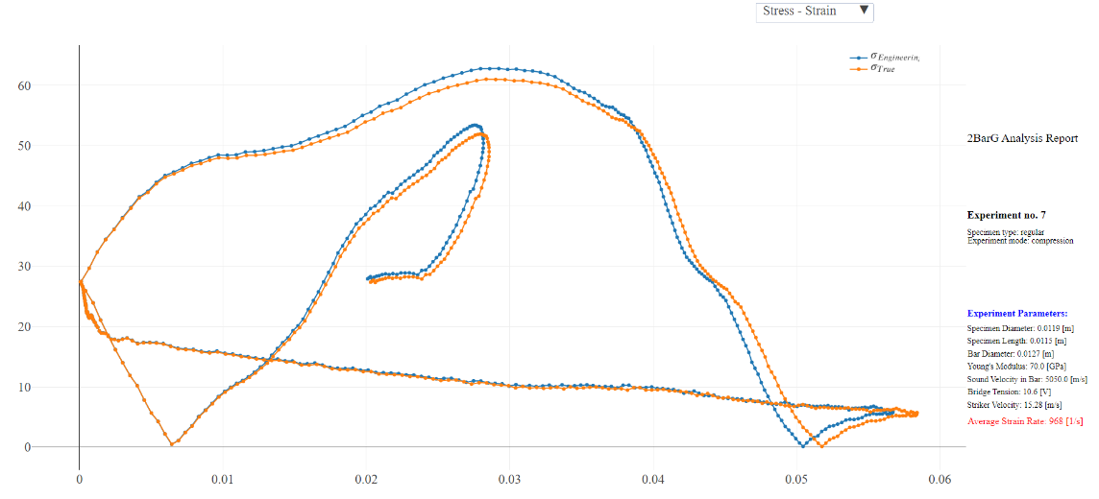

Fig.7. Transparent specimens – Epoxy resin 2 #1.

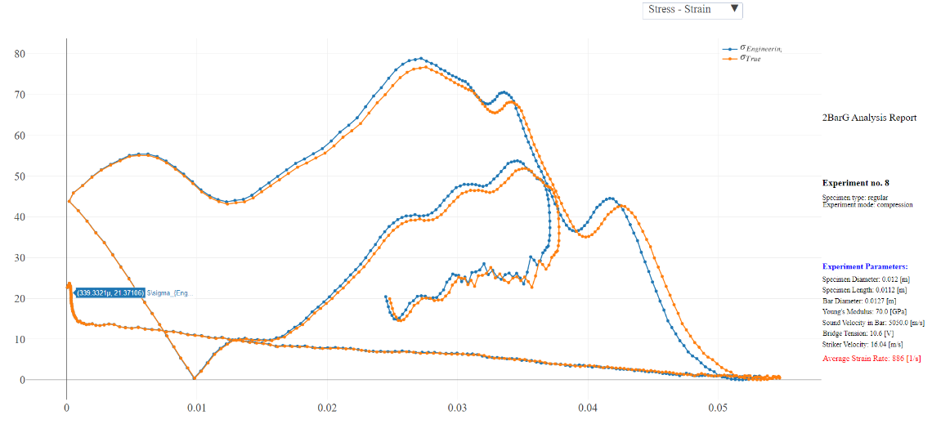

Fig.8. Transparent specimens – Epoxy resin 2 #1.

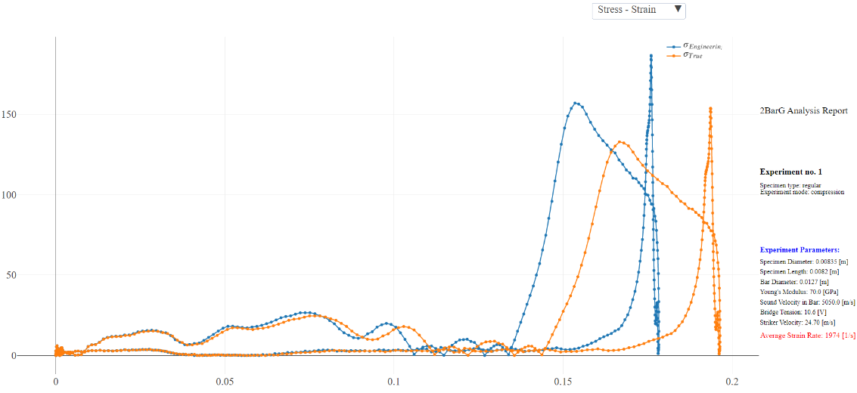

Fig.9. Black specimens – composite #1.

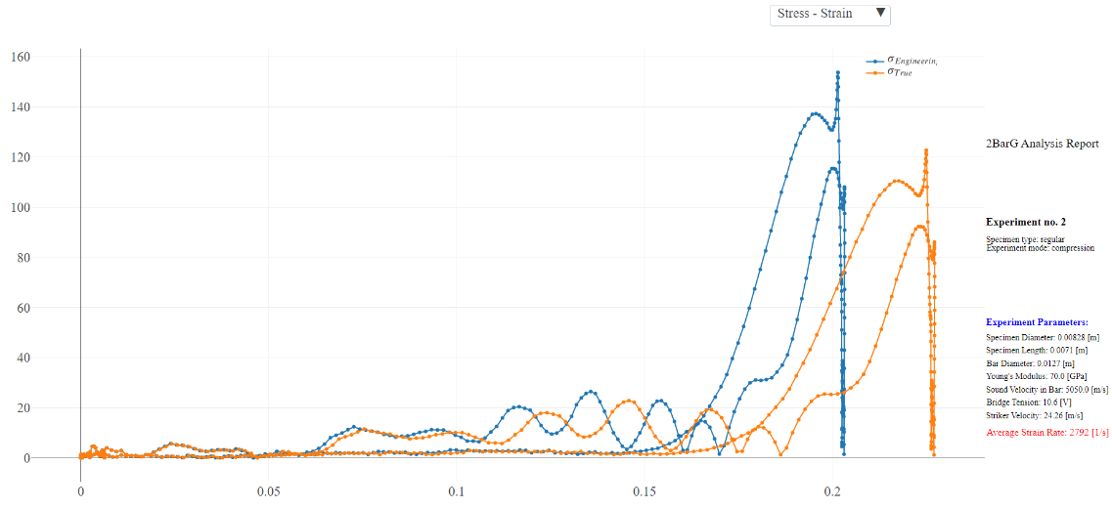

Fig.10. Black specimens – composite #2.

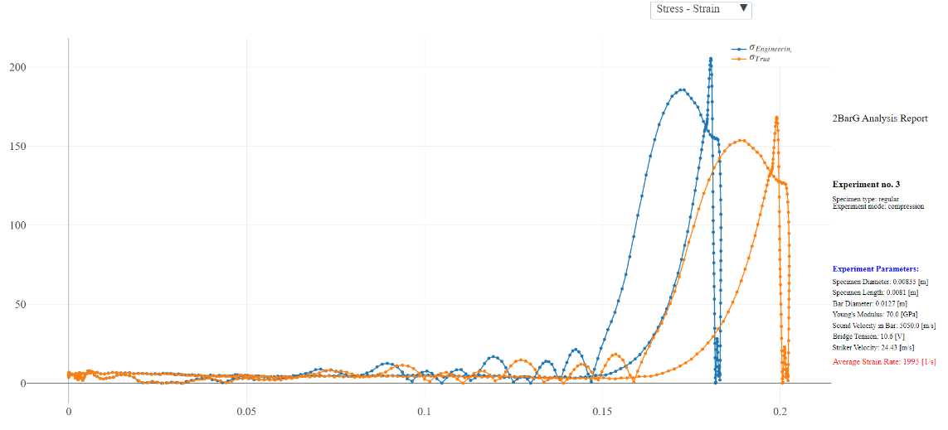

Fig.11. Black specimens – composite #3.

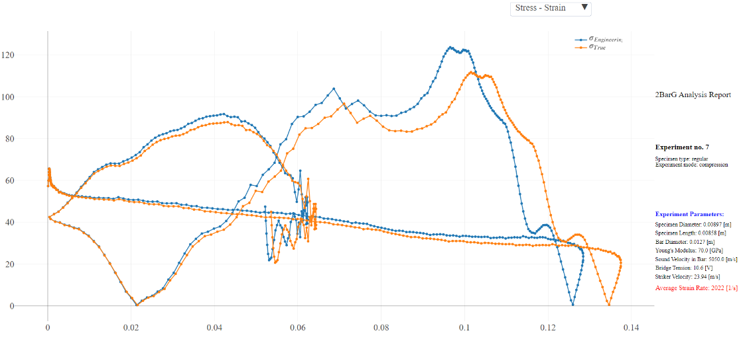

Fig.12. Transparent specimens – Epoxy resin 1 #1.

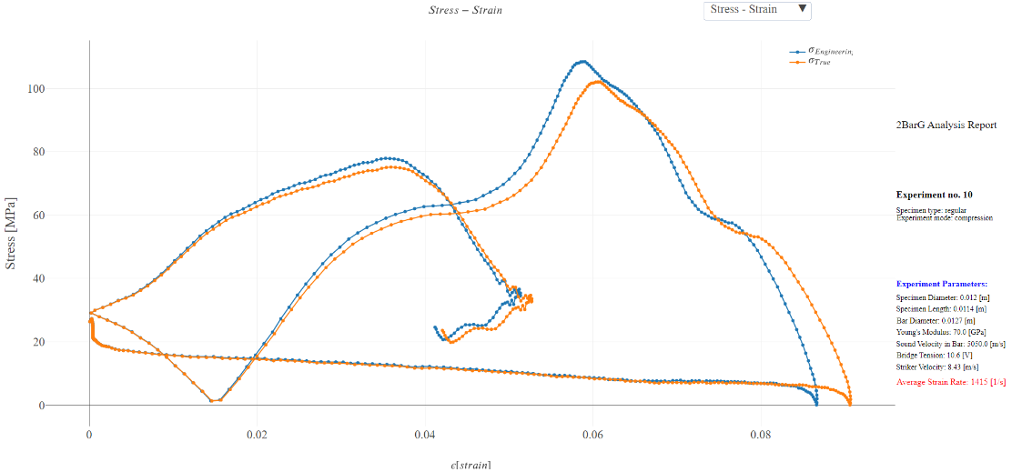

Fig.13. Transparent specimens – Epoxy resin 2 #1.